40G-AOC-A1-XXM

40Gb/s QSFP+ TO QSFP+ Active Optical Cable

Features
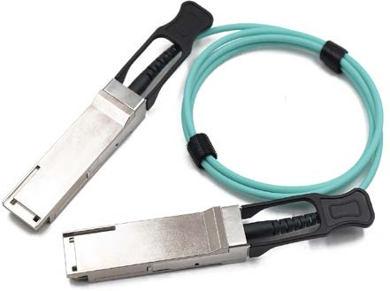
- Support 40GBASE-SR4/QDR application
- Compliant to QSFP+ Electrical MSA SFF-8436
- Multi rate of up to 10.3125Gbps
● +3.3V single power supply
- Low power consumption
- Operating case temp Commercial: 0°C to +70 °C
- RoHS compliant

Applications
- 40GBASE-SR4 at 10.3125Gbps per lane
- InfiniBand QDR
- Other optical links

Absolute Maximum Ratings
Table2- Absolute Maximum Ratings
Parameter | Symbol | Min. | Typical | Max. | Unit | Notes
Supply Voltage | Vcc₃ | -0.5 | - | +3.6 | V
Storage Temperature | T_{s} | -10 | - | +70 | °C
Operating Humidity | RH | +5 | - | +85 | % | 1
Note: 1 No condensation

Recommended Operating Conditions
Table 3- Recommended operating Conditions
Parameter | Symbol | Min. | Typical | Max. | Unit | Notes
Operating Case Temperature | T_{C} | 0 | - | +70 | °C
Power Supply Voltage | Vcc | 3.14 | 3.3 | 3.47 | V

Power Dissipation | Pd | - | - | 1.5 | W | 1
Bit Rate | BR | 1.25 | 10.3125 | - | Gbps
Note: 1 Per terminal

Electrical Characteristics
Table 4- Electrical Characteristics
Parameter |  | Symbol | Min. | Typ. | Max. | Units | Notes
ModSelL | Module Select | VOL | 0 | - | 0.8 | V
ModSelL | Module Unselect | VOH | 2.5 | - | VCC | V
LPMode | Low Power Mode | VIL | 0 | - | 0.8 | V
LPMode | Normal Operation | VIH | 2.5 | - | V_{CC}+0.3 | V
ResetL | Reset | VIL | 0 | - | 0.8 | V
ResetL | Normal Operation | VIH | 2.5 | - | V_{CC}+0.3 | V
ModPrsL | Normal Operation | VOL | 0 | - | 0.4 | V
IntL | Interrupt | VOL | 0 | - | 0.4 | V
IntL | Normal Operation | VoH | 2.4 | - | VCC | V
Electrical transmitter Characteristics
Differential Date Input Swing |  | Vout | 200 | - | 1600 | mV
Output Differential Impedance |  | Z_{D} | 90 | 100 | 110 | Ω
Electrical Receiver Characteristics
Differential Data Output Swing |  | Vin,P-P | 350 | - | 800 | mV_{PP}
Bit Error Rate |  | BER |  |  | E-12 |  | 1
Input Differential Impedance |  | ZIN | 90 | 100 | 110 | Ω
Note: 1 PRBS2^31-1@10.3125Gbps

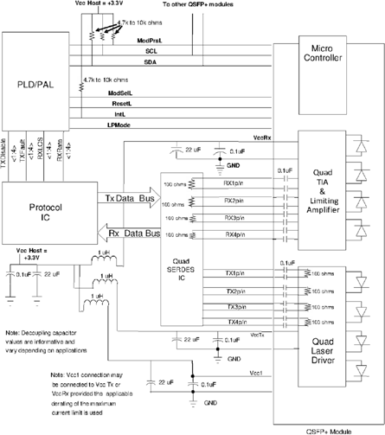
Recommended Interface Circuit
Figure 1, Recommended Interface Circuit

Pin arrangement
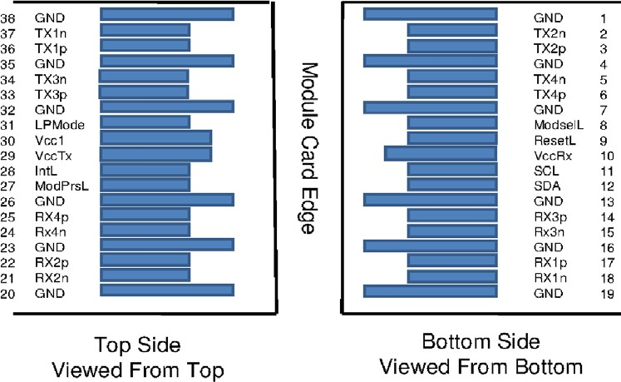

Table 5-Pin Function Definitions
Figure 2, Pin View

Pin | Symbol | Name/Description | Notes
1 | GND | Ground | 1
2 | Tx2n | Transmitter Inverted Data Input
3 | Tx2p | Transmitter Non-Inverted Data Input
4 | GND | Ground | 1
5 | Tx4n | Transmitter Inverted Data Input
6 | Tx4p | Transmitter Non-Inverted Data Input
7 | GND | Ground | 1
8 | ModSelL | Module Select
9 | ResetL | Module Reset
10 | Vcc Rx | +3.3V Power Supply Receiver
11 | SCL | 2-wire serial interface clock
12 | SDA | 2-wire serial interface data
13 | GND | Ground | 1
14 | Rx3p | Receiver Non-Inverted Data Output
15 | Rx3n | Receiver Inverted Data Output
16 | GND | Ground | 1
17 | Rx1p | Receiver Non-Inverted Data Output
18 | Rx1n | Receiver Inverted Data Output
19 | GND | Ground | 1
20 | GND | Ground | 1
21 | Rx2n | Receiver Inverted Data Output
22 | Rx2p | Receiver Non-Inverted Data Output
23 | GND | Ground | 1
24 | Rx4n | Receiver Inverted Data Output
25 | Rx4p | Receiver Non-Inverted Data Output
26 | GND | Ground | 1

27 | ModPrsL | Module Present
28 | IntL | Interrupt
29 | Vcc Tx | +3.3V Power supply transmitter
30 | Vcc1 | +3.3V Power supply
31 | LPMode | Low Power Mode
32 | GND | Ground | 1
33 | Tx3p | Transmitter Non-Inverted Data Input
34 | Tx3n | Transmitter Inverted Data Input
35 | GND | Ground | 1
36 | Tx1p | Transmitter Non-Inverted Data Input
37 | Tx1n | Transmitter Inverted Data Input
38 | GND | Ground | 1
Note: 1. Circuit ground is internally isolated from chassis ground.

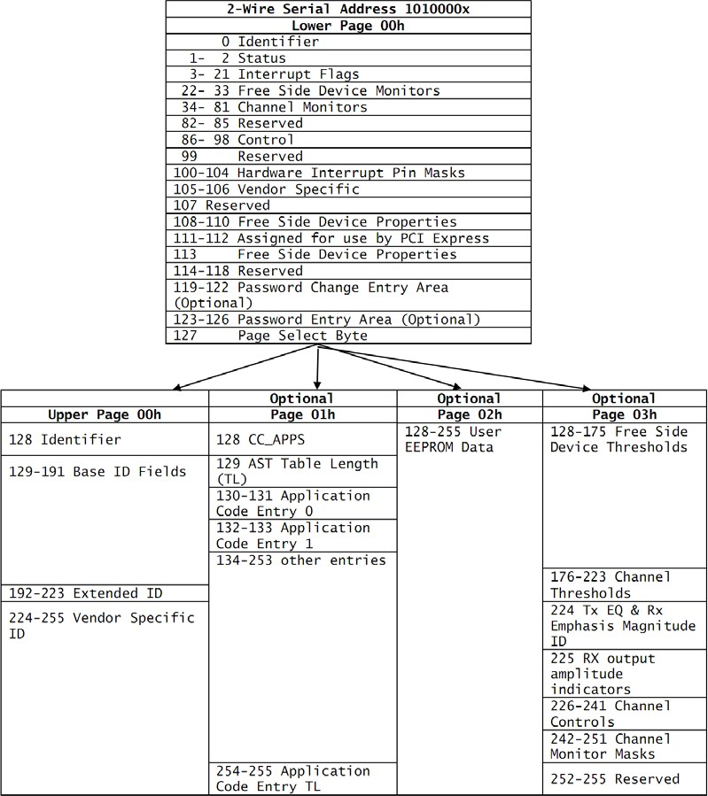
Monitoring Specification
Figure 3, Memory Map

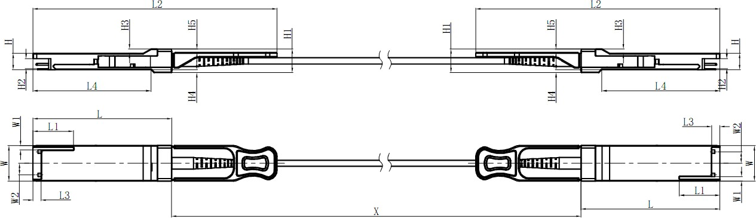
Mechanical
Unit mm
 | L | L1 | L2 | L3 | L4 | W | W1 | W2 | H | H1 | H2 | H3 | H4 | H5 | H6
Max | 72.2 | - | 128 | 4.35 | 61.4 | 18.45 | - | 6.2 | 8.6 | 12.4 | 5.35 | 2.5 | 1.6 | 2.0 | -
Type | 72.0 | - | - | 4.20 | 61.2 | 18.35 | - | - | 8.5 | 12.2 | 5.2 | 2.3 | 1.5 | 1.8 | 6.55
Min | 68.8 | 16.5 | 124 | 4.05 | 61.0 | 18.25 | 2.2 | 5.8 | 8.4 | 12.0 | 5.05 | 2.1 | 1.3 | 1.6 | -

Table 6- Cable Length
Figure 4, Mechanical Diagram

Cable Length（Unit: m） | Tolerant（Unit: cm）
＜1.0 | +5/-0
1.0~4.5 | +15/-0
5.0~14.5 | +30/-0
≥15.0 | +2%/-0

Revision history
Version | Initiated | Reviewed | Revision | Release Date
A0 | Ling | Zhang | New Release | 2018-6-1
A1 | Ling | Zhang | Mechanical Change | 2018-12-28

